**CMSC 203 LAB 4**

**SCREENSHOTS**

***TelevisionDemo.java Screenshot 1***

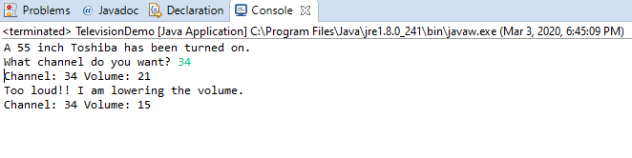

***TelevisionDemo.java Screenshot 2***

